1. 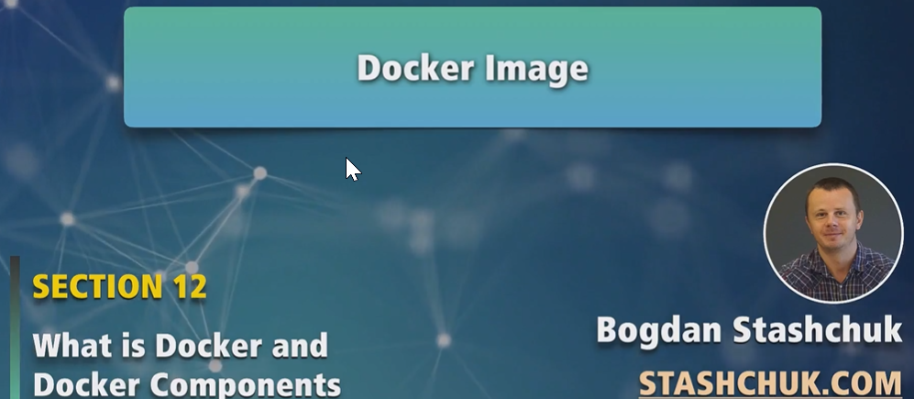
2. Docker host is used to create Docker processes which in turn create containers on the machine.
3. **Docker Image**: Simply a set of read-only files.
   1. Based on image, we can create container or different containers.
4. Let’s see a list of containers which are already present on my computer.
5. 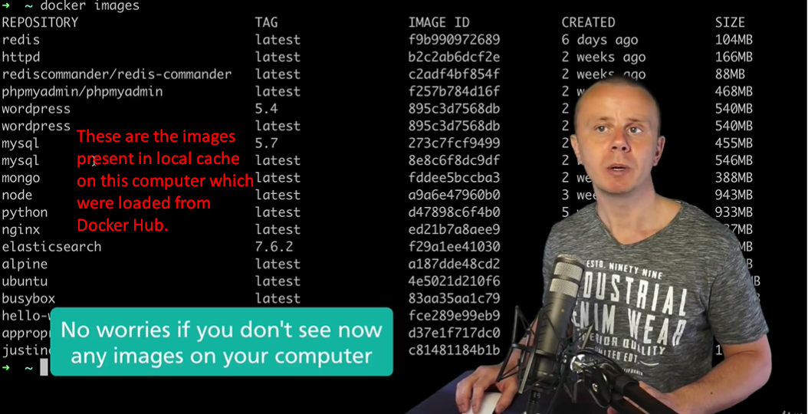  
   We know that these **Docker images** are loaded from **Docker Hub**.
6. The above images are created by someone else but we can create our custom image too.